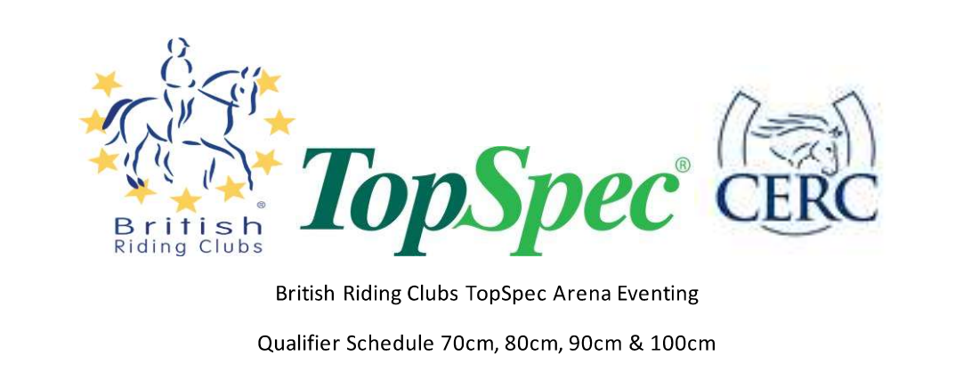

British Riding Clubs Area 9 Arena Eventing Qualifier Schedule

70cm, 80cm, 90cm & 100cm

**Sunday 12th October 2025**

West Wilts EC, Holt, Trowbridge BA14 6QT

|  |  |  |
| --- | --- | --- |
| **Class Number** | **Class Name** | **Entry Fee** |
| 1 | 70cm Junior (team) | £128 |
| 2 | 70cm Junior Individual | £32 |
| 3 | 70cm Senior (Team) | £128 |
| 4 | 70cm Senior (individual) | £32 |
| 5 | 70cm Mixed (individual unaffiliated - not BRC qualifier) | £32 |
| 6 | 80cm Junior (team) | £128 |
| 7 | 80cm Junior (individual) | £32 |
| 8 | 80cm Senior (team) | £128 |
| 9 | 80cm Senior (individual) | £32 |
| 10 | 80cm mixed (individual unaffiliated - not BRC qualifier) | £32 |
| 11 | 90cm Mixed (team) | £128 |
| 12 | 90cm Mixed (individual) | £32 |
| 13 | 100cm Mixed (team) | £128 |
| 14 | 100cm Mixed (individual) | £32 |

Eligibility for all classes can be found in the current BRC handbook. Eligibility will be taken from the Friday before the qualifier. All competitors competing in BRC qualifier classes must be a current BRC member and be on the database by midday the Friday before the competition. Any competitor failing to meet the eligibility criteria will be disqualified and informed by BRC HQ once the results are processed.

This competition will run under BRC rules 2025, with anyone in attendance bound by the BRC Code of Conduct. It is important that all competitors are aware of the rules relating to this competition - please see the current BRC handbook and also the BRC Rule Amendments and Changes Document for guidance.

All BRC Qualifier entrants must have purchased a BRC competition pass through Sport.80 prior to entering (note: this replaces the pre-entry system). Entries made without a pass will not be accepted, and each rider’s pass number MUST be provided for entries to be valid. Entries close 10 days before the competition (2nd October 2025). Late entries may be accepted at the discretion of the organiser with a late surcharge of £10 per individual and £20 per team, if space allows. Late entries cannot be guaranteed and so therefore must not be paid for until approval from the organiser is gained.

Once the BRC competition pass has been purchased, an area entry must be made via the details outlined on this schedule and sent to the entries secretary: Caroline Rich, Bracken House, Silver Street, Minety, Wiltshire SN16 9QU

**Starting times will be available on the area 9 website from Thursday 9th October 2025.**

**Hat Tagging & Body Protectors**

Hat and Body Protector standards accepted in all BRC competitions and guidelines to follow can be found on the BRC website . All members are required to have their hats tagged before competing in any BRC qualifier or championship. All competitors must wear a Body Protector up to the current standards specified in the guidelines**.** Hard hats must be worn and chin strap fastened by all riders when mounted, conforming to one of the following - PAS015 2011, VG1 01.040: 2014-12 marked with the BSI Kite-mark / Inspec IC. ASTM F1163 (2015 onwards) marked SEI Mark. SNELL 2016 or 2021 onwards. AS/NZS 3838 (2006 onwards) marked with the SAI Global Mark, BS EN 1384 (2023) NO OTHER SPECIFICATION WILL BE PERMITTED. All competitors must have the pink hat tag with either BRC, PC or BE logos. Failure to do so will result in elimination.

**Organiser and Secretary** Cotswold Edge Riding Club. Caroline Rich. Email: [caroline.rich603@gmail.com](mailto:caroline.rich603@gmail.com)

**Warm up time** is limited to 30 minutes prior to your start time. Please follow the stewards instructions at all times

**Owners and riders** enter at their own risk

**Vet** on call

**Horses and Ponies** may only enter two classes of consecutive heights. May not be left unattended, tied to horseboxes or trailers. Warm up is only permitted in the designated area. Lunging is not permitted. All horses or ponies must be 4 years or over.

**Riders** if riding more than one horse/pony please highlight on the entry form. Please bring your own bibs and numbers and ensure you are wearing the correct number, when mounted, at all times. There is a pro forma on the BRC website to to assist in printing numbers

**Course** will consist of a maximum of 9 show jumps followed by a maximum of 10 XC style rustic fences and a final joker fence set to a maximum of 10cm higher than the rest of the course. The Joker fence is a compulsory fence and must be jumped, failure to jump before passing through the finish will be classed as an error of course and penalised as set out within the BRC handbook (2025). Scoring will be conducted as set out within the BRC handbook (2025).

Numbers to qualify as per relevant appendix in the BRC Handbook.

All Team managers ensure that horses flu vaccinations are up to date as per the BRC 2025 rules and are on the Area Database prior to the competition.

The judge's decision in relation to the competition results and that of the official steward in relation to all matters will be final. Protests or complaints to be lodged to Caroline Rich (07984 721325) with a £25 deposit, no later than 30 minutes after the occurrence. The deposit will be forfeited unless the objection is upheld.

**Health & Safety** The organisers of this event have taken reasonable precautions to ensure the health and safety of everyone present. For these measures to be effective everyone must take all reasonable precautions to avoid and prevent accidents occurring and must obey the instructions of the Organisers and Officials and Stewards

**Legal liability** Horse / pony sports can be dangerous, and animals are unpredictable. Neither the committee of The Cotswold Edge Riding Club or any person acting on their behalf or the landowners can accept any liability for the loss, damage, accident or injury to any person or property. It is a condition of entry that each entrant agrees to indemnify the above persons against any legal action arising from such an incident

**All persons attending the show will be deemed to have accepted these rules and conditions.**